**SET – I**

**Q. No 1. Define international Business. What are the various factors affecting international Business?**

**Definition international Business**

**Various factors affecting international Business**

International business is mainly concerned with the issues that are related to international companies and governments’ cross border transactions. International business involves multiple countries to satisfy the objectives of every individual as well as the organizations. International business management is a process of achieving the global objectives of a firm by effectively managing the human, financial, intellectual and physical resources.

**Definition international Business =>**

International business can be defined as any business that crosses the national borders of a country. It includes importing and exporting; international movement of goods, services, employees, technology, licensing, and franchising of intellectual property (trademarks, patents, copyright and so on). International business includes investment in financial and immovable assets in foreign countries. Contract manufacturing or assembly of products for local sale or for export to other countries, establishment of foreign warehousing and distribution systems, and import of goods from one foreign country to a second foreign country for subsequent local sale is part of international business.

**Various factors affecting international Business =>**

There are various factors that affect international business. These factors include economic environment, culture, political environment, financial and banking systems, regulatory bodies, human capital, and trade policies and so on, of the target country.

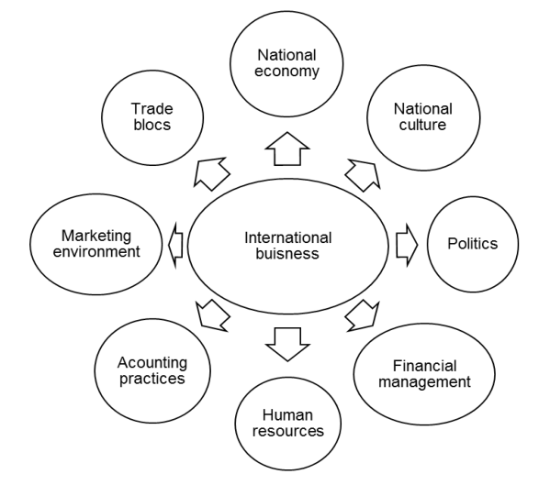

In a rapidly changing global economic scenario under World Trade Organization, starting an international business is considered to be more complex than starting a domestic business. There are two specific reasons for it.

1. The numbers of parties involved in international trade are more than domestic business. Such parties may include customs officials, Director General of Foreign Trade, Reserve Bank of India, excise officials and duty drawback officials, insurance companies, shipping companies, freight forwarders, and banks except exporter and importer himself. All of them help in administering, regulating, facilitating and financing the export-import business.
2. The distances involved in trade transaction, differences in business etiquettes and practices in different countries, varied cultures, languages, preferences and currencies complicate the process and the exporters need to have near accurate, comprehensive and complete information at the right time for a successful international trade entry. It is not an easy job as the information flows as well as export and import related formalities keep on changing on a continuous basis.

If such information on country’s cultural, economic and social aspects is successfully administered, traders will have following advantages in successfully conducting the business.

* Speedy delivery of internationally traded goods
* Quicker release of payments in trade transactions
* Generating economies of scale by expanding and diversifying business to overseas markets.
* Reduced transactional costs in trade
* Retaining satisfied customers.
* Higher returns on sales, as nations usually do not impose duties and taxes on exportable goods and services.
* Higher learning curves through feedback for international customers which help trader to customized and improve product or service on regular basis.
* Maximizing overall returns from international business.

**Q. No 2. Explain detail structure of WTO with diagram.**

**Structure of WTO with Diagram.**

The WTO is the successor to the General Agreement of Tariffs and Trade (GATT). India is one of the founders of WTO. WTO represents the latest attempts to create an organizational focal point for liberal trade management and to consolidate a global organizational structure to govern world affairs. WTO has attempted to create various organizational attentions for regulation of international trade. WTO created a qualitative change in international trade. It is the only international body that deals with the rules of trades between nations.

**Structure of WTO with Diagram =>**

The structure of the WTO consists of the Ministerial Conference, which is the highest authority. This body consists of the representatives from all WTO members. The members meet once in every two years and decisions on all matters regarding the multilateral trade agreements are taken. Subsidiary bodies and the General Council composing of WTO members undertake the daily activities of the WTO. The members report to the Ministerial Conference. On behalf of the Ministerial Conference the General Council administers as the Dispute Settlement Body to handle the dispute settlement procedures. It also acts as the Trade Policy Review Body that regularly reviews the trade policies of individual WTO members.

The General Council delegates responsibility to other major bodies. They are:

* **Council for Trade in Goods**:

It manages the implementation and functioning of all agreements covering trade in goods

* **Trade in Services and Trade of Intellectual Property Rights:**

These two councils are responsible for their respective WTO agreements. They can also establish their own subsidiary bodies, if required.

* **Committee on Trade and Development:**

It handles issues related to the developing countries.

* **The Committee on Balance of Payments:**

Consultations between WTO members and countries that take trade-restrictive measures to handle balance-of-payments difficulties.

* **Committee on Budget and Administration:**

Issues concerning financing and budget of WTO are handled by them.

Diagram:

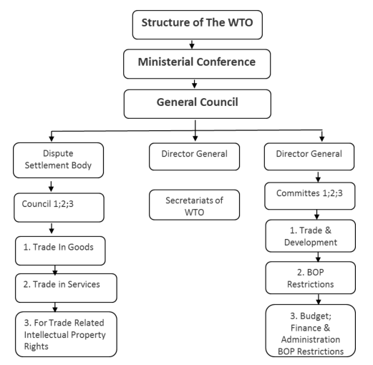

**Q. No 3. Write a short note on international regulatory bodies.**

**European Union**

**United Nations**

**OECD**

**IASC**

**IFA**

Certain regulatory bodies are active in bringing out harmonization of accounting standards. Efforts of some of the bodies are explained here.

**European Union =>**

European Union is pro-active in the harmonization process. European Commission sets directives, which are orders to the member countries, to bring their laws in line with EU needs, within some transition period. The earlier accounting directives are:

* The nature and design of financial statements.
* The measurement support on which the financial statements are to be organized.
* The significance of consolidated financial statements.
* The need that auditors should ensure that the financial statements reflect a true perspective of the organization’s operations.

Though the EU has enhanced the comparability of financial statements, the directives do not cover several essential issues. Additionally, some directives provide options, but member countries understand the directives differently. Thus, EU organizations listing outside their home-countries must supply the following two sets of financial statements, they are:

* Home-country statements.
* Reconciliation statements.

**United nations =>**

The United Nations is interested in international accounting since the early 1970s and has been operating under a 'Group of Eminent Persons'. This further led to the establishment of Intergovernmental Working Group of Experts on International Standards of Accounting and Reporting (ISAR) by the UN Economic and Social Council.

The ISAR attempts to support the developing countries, by creating recommendations on the accessibility and comparability of information disclosed by international businesses.

The discussions of the ISAR are reported in annual publications. Publications cover accounting developments worldwide, and reports on issues significant to global accounting.

The ISAR is presently concerned about developing discussions on the international environment reporting, and the role and responsibilities of accountants and auditors.

**OECD =>**

Organization for Economic Cooperation and Development was established by world's 24 developed countries, of which some are Australia, Austria, Belgium, and Canada. This was set up for promoting world trade and international economic growth. This looks at matters from the perspective of economically developed countries. The council of OECD has established a committee on International Investment and Multinational Enterprises (MNEs). This committee in turn has established a Working Group on Accounting Standards.

The ‘Working Group’ has recently published a 'Clarification of the OECD Guidelines', and published reports as an element of an 'Accounting Standards Harmonisation' series. Most recently, the OECD has established a 'Centre for European Economies in Transition', which along with ‘Working Group’ has prepared workshops, seminars, and meetings, to recognize the purpose and constituents of accounting systems in these countries.

**IASC =>**

International Accounting Standards Committee was created in the year 1973. It has issued a series of standards to harmonize management of accounting issues globally. The chief objective of IASC is the

encouragement of comparability of financial statements between countries, by establishing standards for inventory assessment, depreciation, delayed income taxes, and so on.

An important accomplishment of the IASC has been the creation of the International Accounting Standards (IAS). The publication and global recognition of these standards are necessary for the harmonization efforts of the IASC.

**IFA =>**

The International Federation of Accountants was founded in the year 1977. It completely supports the work of the IASC, and recognizes the IASC as having responsibility and authority to issue rules on international accounting standards. IFA has parallel responsibility of IASC’s objective of developing international guidelines for auditing, ethics, education and management accounting.

Some of the other international regulatory bodies are:

* Governmental Accounting Standards Board.
* Independence Standards Board.
* International Accounting Standards Board.
* International Organisation for Securities Commission.
* National Association of State Boards of Accountancy.
* Public Company Accounting Oversight Board.
* UK Accounting Standards Board.

**SET - II**

**Q. No 1. What are the four methods of payment for the international Transactions?**

**Payment Methods**

**Payment Methods =>**

Since international trade deals with exchange of goods, there are various ways in which the payment terms (finance) will be handled.

Bothe seller and trader should be careful about the method of payment as they are at different locations and transactions happen without face-to-face interaction. There are four methods of payment for the international transactions. This includes the Cash-in-advance method, Letter of Credit, Documentary collections and the Open Account.

These are shown below –

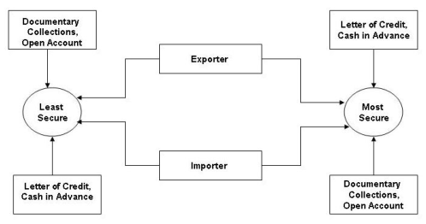

There is uncertainty during the time when payment transactions happen between importer and exporter. The figure compares and contrasts the most suitable methodology from the perspective of importer and exporter. Apparently the most secure methodologies that work for the exporter is not safe for the importer. For exporters, documentary collection and open account are less secure and letter of credit and cash in advance are more secure methods. In the same way, with respect to the importer, the letter of credit and cash in advance are less secure and the documentary collection and open account are more secure.

These terms are explained as follows:

* **Cash-in-advance**

Cash-in-advance helps in removing the risks of credit by the exporter. By this method, exporter receives the payment before the transfer of goods. The options that are available with the cash-in-advance method include wire transfers and credit cards. This is the least attractive method for many of the buyers as it creates cash flow problems. The buyers are concerned about the quality/quantity and delivery of the goods that are not sent if the payment is made in advance.

* **Letters of credit**

The letter of credit is the most secure instrument available for international traders. This is the commitment made by the bank that the payment will be made to the exporter if the terms and conditions are met. The terms and conditions of the payment are explained in the required documents.

* **Documentary collections**

Documentary collection is a transaction in which, the exporter's bank (remitter bank) sends the documents to the importer's bank (collecting bank). The document contains information about the payment. The funds are collected from the importer and paid to the exporter through the banks involved in the collection, in exchange for the documents.

* **Open account**

The open account transaction involves the shipping and delivery of goods in advance. The payment is due usually from 30 to 90 days. This is advantageous for the importer in cash flow and cost terms, but at the same time it is very risky for the exporters. Buyers from abroad stress on open accounts since the extension of credit from the seller to the buyer are more common in many countries. Exporters who avoid extending credit may face loss in the sale because of competitors in the market.

**Q. No 2. Explain in detail about short-term credit and long-term credit.**

**Short term credit**

**long term credit**

The export credit in India is studied with response to its two stages. The two stages are the pre-shipment credit and the post-shipment credit. The pre-shipment credit is mainly used for production, processing and packaging. The post-shipment credit is mainly required to finance the foreign buyers. Depending on the period of loans, there are three types of credits–short term, medium term and long-term credit.

**Short term credit =>**

The short-term credit is provided in the form of pre-shipment and post-shipment finance. This can be provided by the commercial banks that are authorized dealers in the foreign exchange. Short term credits are covered by RBI and provide credits at lower rate of interest. In relation to this type of credit, there are two schemes that are explained as follows:

* The Pre-shipment Credit in Foreign Currency (PCFC) in which the exporters can take the credit both in rupees as well as, the foreign currency. We get the credit in Indian rupees at base rate+1% of interest and the foreign exchange at London interbank offered rate (LIBOR)+1% rate of interest. Concessional pre-shipment credit as per RBI rules can be for 6 months.
* The second scheme is the post-shipment credit that is available in Indian rupees. This post-shipment credit rate of interest is available in Indian currency which does not exceed 13% for a maximum of 180 days. Higher rate of interest is charged when post-shipment finance is availed for more than 6 months.

**long term credit =>**

Long term credit is provided by the EXIM bank and the commercial banks that are refinanced by the IDBI. The important aspect of export credit is the risk of transacting with the overseas buyers. The risks with the foreign buyers occur due to the insolvency of the buyers when there are fluctuations in exchange rates and some government actions that cause delay in the payment to exporters. These types of risks can be averted by the insured Export Credit and Guarantee Corporation (ECGC). This corporation offers two types of services that are given as below:

* The export credit insurance, which consists of the policies that are issued to the exporters to protect themselves against the losses that occur from granting credit terms to the foreign buyers.
* The direct guarantees are the guarantees to the banks that give protection in respect of exporters.

**Q. No 3. What are the various advantages of global sourcing?**

**Advantages of Global Sourcing**

**Advantages of Global sourcing =>**

As business operations diversified in the global production chain due to globalization, companies have to evaluate their choices, decisions and strategy for outsourcing different components at a cost-effective level from all around the world. Outsourcing offers several advantages as different countries are endowed with different natural, physical and demographic resources. Multinationals spread their production to low cost, developing countries. Business operations are shifted to many countries depending on the comparative and competitive advantage. Global sourcing has actually helped multinational enterprises to grow and save money. There are other advantages of global sourcing that go beyond financial benefits. Detailed below are some advantages that prompt companies to sources globally for cost, reliability and efficiency reasons.

* **Benefits of core competency:**

A large company offering products and services in many segments and industries need to constantly focus on delivering innovative products. Larger business organization sometimes develop stagnancy due to their back-office operations which may affect its core function or activities. Therefore, such companies usually outsource their noncore activities to other companies.

For example, for a pharma company it is important that its manpower focuses on research and innovation of new drugs, but if it expands its organization to resolve problems such as order processing, managing inventory, warehousing, documentation, booking new orders and handling customer problems it will make the organization redundant since most of its top management energy will go into non core issues. Outsourcing these non core activities can make firms lean, fast, cost-effective and competitive in the market.

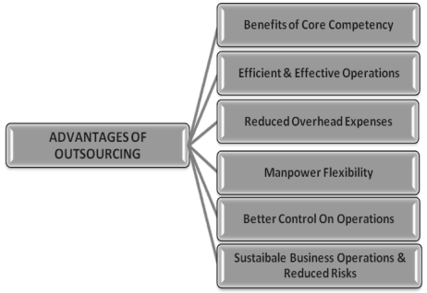

* **Effective and efficient business operations:**

Back office operations for any firm in today’s’ competitive environment are not only complicated in nature but also expensive in terms of both financial resources and time. Organizations can focus on core strength when such non allied activities are outsourced at consistent and reasonable cost. Outsourcing such operations can help firms tide over such problems areas.

* **Reduced overhead expenses:**

Firms have to outsource some of their functions to cost-effective destinations as overhead costs of performing a particular back-office function may be extremely high in its own country due to different factor endowments. For example, medical transcription which is considered as a non core activity is outsourced to India by US firms. India is considered as most cost-effective, cost competitive and is a strong market leader in medical transcription outsourcing because of its large resource of young, college educated and productive workforce. Indians are also good in the use of the English language. Globally, firms are looking at India’s best-in-class medical transcription training methodologies for outsourcing their work in medical transcription outsourcing.

* **Better control of operations:**

Any business operations for which costs are running out of control is better outsourced. Sometimes, there are certain departments that may have evolved over time into uncontrolled and poorly managed areas. This becomes a prime motivator for outsourcing. Outsourcing such departments to another country/region help the firm learn/imbibe better management skills, innovation and practices.

* **Manpower staffing flexibility:**

Outsourcing seasonal/cyclical business operations also help firms save costs. There are seasonal or cyclical demands of goods and services requiring additional manpower resources from firms. Firms can outsource such operations to another region/country where labour expenses may be just a fraction of what it is in the domestic market. For example, taxation of many US states has been successfully outsourced to Indian firms.

* **Sustainable business operations and reduced risks:**

Due to uncertain business scenarios and the changing demographic profile of countries, there have been trends and periods of high employee turnover which add uncertainty and inconsistency to a firm’s business operations. More so, it has been observed that sometimes a region of the world may go into turmoil, civil disorder, God or manmade catastrophes, etc. If a firm’s business operations are outsourced to different parts of the world, it can survive from such risks and can ensure sustainable business operations.

For example, due to the Jasmine revolution many multinationals survived even after the shutdown of their businesses in the Gulf/Arab region. Firms who had outsourced their activities to multiple regions were able to fulfil their client/customer needs from another part of the world.